Camps

Disclaimer: Silent Voyces does not advocate or recommend a specific agency, program or service.

This information is supplied as a reference if you choose to use it. This list is provided as a courtesy and is not a complete or comprehensive list of providers. Silent Voyces does not endorse or recommend any service provider, and no employee of Silent Voyces is authorized to make any such endorsement or recommendation.

FAMILY CAMP/FAMILY RETREAT
Many organizations offer Family Camp or Family Retreat models specifically designed for children with disabilities, allowing parents and siblings to participate together. These camps often provide specialized medical staff, accessible facilities, and a mix of family activities and parent-only respite time.

1. Victory Junction (Randleman, North Carolina)
Founded by the Petty family (of NASCAR fame), this camp serves children with serious illnesses and chronic medical conditions.
- Program: They offer Family Weekends where the entire family stays in a private cabin.
- Activities: Archery, horseback riding, fishing, and "The Track" (an accessible racing experience).
- Cost: No cost to families.
2. Morgan’s Wonderland Camp (San Antonio, Texas)
Part of the "Ultra-Accessible" Morgan’s Wonderland theme park family, this camp is designed to be barrier-free for everyone.
- Program: They host specialized Family Retreats and partner with various disability-specific organizations for weekend camps.
- Activities: Accessible zip-lining, swimming in a heated pool with ramp access, and challenge courses.
3. Center for Courageous Kids (Scottsville, Kentucky)
A world-class medical camp that provides a traditional camping experience for children with a variety of diagnoses.
- Program: They offer Family Retreat Weekends throughout the spring and fall for specific conditions (e.g., Autism, Spina Bifida, Cerebral Palsy).
- Activities: Equestrian programs, bowling, and arts and crafts in a medically supervised environment.
- Cost: Completely free for families.

4. Camp John Marc (Meridian, Texas)
Located on a 170-acre ranch, this camp specializes in serving children with chronic medical physical challenges.
- Program: They host over 25 family weekend camps a year in partnership with pediatric hospitals.
- Focus: Strong emphasis on the "family unit," providing activities that siblings and parents can do alongside the camper.
5. Camp Accomplish (Dahlgren, Virginia)
Operated by Melwood, this camp offers an inclusive environment for campers with and without disabilities.
- Program: Their Family Camp is customized for families to experience activities together, including specialized adult support groups.
- Specifics: They offer sessions for Autism, Intellectual Disabilities, and various chronic health conditions.
6. Easterseals Camp Sunnyside (Des Moines, Iowa)
One of the most well-known Easterseals locations, offering a vast array of accessible outdoor fun.
- Program: While they focus heavily on resident camps, they offer Family Camp weekends where parents join in to learn more about adaptive recreation.
- Activities: Indoor accessible pool, rock wall climbing, and an animal farm.
7. Camp For All (Burton, Texas)
A barrier-free camp that works with over 65 non-profit partners to provide specialized sessions.
- Program: Many of their partner sessions are Family Camps where parents stay on-site to enjoy the universal programming.
- Activities: Every activity—from the high ropes course to canoeing—is designed to be accessible to someone in a wheelchair.
8. Double H Ranch (Lake Luzerne, New York)
Co-founded by Paul Newman, this is part of the "SeriousFun Children's Network."
- Program: They offer Family Sleepaway Weekends during the spring and fall.
- Activities: Adaptive skiing (in winter), swimming, and high ropes.
- Cost: All programs are free of charge.
9. Camp Korey (Mount Vernon, Washington)
Another member of the SeriousFun Children's Network, serving the Pacific Northwest.
- Program: Their Family Weekends provide a safe, "medical-heavy" environment where parents can relax while children play under expert supervision.
- Focus: Sessions are often condition-specific, such as for skeletal dysplasia or solid organ transplants.

10. Camp Boggy Creek (Eustis, Florida)
A year-round retreat for children with serious illnesses and their families.
- Program: Family Retreat Weekends allow families to bond and meet others navigating similar medical journeys.
- Activities: Theatre, woodshop, and fishing.
- Cost: No cost to families.

SUMMER CAMPS

Frisco Parks & Recreation  5828 Nancy Jane Lane  Frisco, TX 75035  (classes/camps held at various Frisco locations) | Frisco Parks & Rec released their 2023 Summer Fun Guide! Registration is now open for summer activities. You can view their course offerings here.  If you would like to discuss your child's needs related to recreational programming, please reach out to CJ Higginbotham (chigginbotham@friscotexas.gov) or Carter Patton (cpatton@friscotexas.gov).
Sound Starts Music Therapy Camps | Music Therapy camps will be held in June and July.  Camp | Sound Starts Music Therapy
Prestonwood KIDZ Adventure Week  Plano campus (972) 820-5333  North campus (972) 798-6731 | Vacation Bible School (Christian) specifically for children with special needs. Morning & evening options available.  KIDZ Adventure Week - Prestonwood Baptist Church
Texas Elks Camp  1963 FM 1586 Gonzales, Texas  (830) 875-2425 | No cost camp for children with special needs or in foster care, ages 7 to 16.  Texas Elks Camp
Starcatchers Therapeutic Arts-  Theatre Summer Camp  Willow Bend Center of the Arts  6121 W. Park Blvd. B216  Plano, TX 75093 | Starcatchers is NTPA’s Therapeutic Arts program designed specifically for children and adults with cognitive disabilities. In this program, students are given opportunities to shine through drama, music, dance, and visual art.  Have you ever wanted to be in a musical? Do you like telling stories, dancing, singing, or drawing? Then come try out a Starcatchers Creative Arts Camp this summer!  These camps are designed for youth and adults with disabilities to learn the fundamentals of putting on a theatrical production. Under the direction of therapeutically minded staff, campers will create stories, develop characters, create set pieces, and put together a short theatrical production. Each camp has a specific theme and will end with a performance showcase for families to watch.  All new students can sign up now for 50% off your first camp!  https://ntpa.asapconnected.com/#CourseID=187139
Alphabest Summer Bridge Program  (972) 668-0640 | Summer enrichment programs  Summer - AlphaBEST
Texas Hands and Voices  P.O. Box 2208  Cypress, TX 77410  (936) 463-8948 | Camps for children with hearing impairments  Texas Hands & Voices™  https://txhv.org/eventcalendar
YMCA Summer Camp Serves North Texas | www.ymcadallas.org/summer  frisco summer day camps
Camp on the Lake  Several Locations  (214) 367-8431 | A waterfront day camp serving families in Lewisville, Flower Mound, Frisco, Plano, Park Cities, Coppell and North Dallas area (ages 6-13).  www.CampOnTheLake.org
Charis Hills  498 Faulkner Road  Sunset, TX 76270  (904) 964-2145 | Overnight 1 week camp for children with learning disabilities/social skills deficits (ages 7-18)  www.charishills.org
Collin County Adventure Camp  1180 W. Houston Street  Anna, Texas 75409  (215) 667-5600 | Day Camp for ages 5-15  Overnight Camp for ages 7-15  www.CollinCountyAdventureCamp.org
HEROES - Helping Everyone Reach Outstanding Educational Success  101 S. Coit Road #36-348  Richardson, Texas 75080  (972) 663-5853 | Day Camp - all ages - strives to create social, recreational and vocational programs for individuals with disabilities.  www.heroesdfw.org
ARC of Dallas  12700 Hillcrest Road #200  Dallas, Texas 75230  (214) 634-9810 | Adventure Camp - Day camp for children with special needs /  Ages 5-21  The Arc of DFW Area
Callier Center  1966 Inwood Drive  Dallas, TX 75235  (214) 905-3000 | Camps that support social skills, language development, and reading skills. They are also hosting a camp specifically for children with hearing loss.  Summer Camps - Callier Center for Communication Disorders
Moran Camp Xtreme  Burton - (979) 289-3752  Houston - (713) 797-5997 | Through a variety of team sports, individual challenges, and a lot of healthy competition, the kids at Moran Camp Xtreme reach new levels of independence, self-awareness, and confidence.  Physical disabilities and/or mobility impairments, ages 8-21 (adding new adult camp)  Burton, Texas (Camp For All)  San Antonio (Morgan's Wonderland)  Burton - 979-289-3752  Houston - 713-797-5997  Moran Camp Xtreme - TIRR Foundation
C.A.S.T for Kids  (541) 992-0441 | Fishing experiences for children with disabilities. Hosted in a variety of Texas cities this summer.  CAST for Kids Foundation  C.A.S.T. for Kids - Joe Pool Lake Presented By Texas Farm Bureau Insurance
Dallas Zoo Camps  650 South RL Thornton Freeway  Dallas, Texas  (469) 554-7500 | Dallas Zoo
Texas Lions Camp  P.O. Box 290247  Kerrville, Texas 78029  (830) 896-8500 | Camp for children with special needs, ages 7-16.  www.lionscamp.com
Angel Camp  Rockwall, Texas  (972) 772-9622 | Day camp for children with special needs ages 5-18  www.ymcadallas.org/locations/jerchiltonymca/angel_camp/
Champions Special Ministries  5333 Independence Pkwy  Plano, TX 75023  (913) 638-6823 | Day camp for children with special needs  www.championsspecialministries.com
Camp Blessing  7227 Camp Blessing Lane  Brenham, Texas  281-259-5789 | Camp Blessing is a residential Christian summer camp offering love, acceptance and fun to children and young adults with special needs (ages 7+) and their siblings.  Campers should have a diagnosis of an intellectual &/or physical disability that would otherwise render them unable to attend a traditional youth camp.  Camp Blessing
CAMP Camp  Center Point, Texas (camp)  San Antonio, Texas (office)  (210) 671-5411 | Camp for children and adults with special needs who may not be eligible to attend other camps due to the severity of their disability or medical condition. In addition to summer camps, other events include Family Adventure Day, Family Weekend Retreats, Parents' Night Out, Respite Camps, and Teen & Adult Adventure Day. Camp for children with special needs (ages 5-50)  Individuals with mild to severe disabilities (Autism, Intellectual Disability, Down syndrome, Cerebral Palsy, Spina Bifida, visual impairment, and hearing impairment). Also serve the non-disabled siblings of campers.  Camp CAMP
Camp Carter (Camp Can-Do)  6200 Sand Springs Rd  Ft. Worth, TX 76114  (817) 738-9241 | Day camp for children with special needs  www.campcarter.org
Camp for All  6301 Rehburg Road  Burton, TX 77835  (979) 289-3752 | www.campforall.org
United Through Hope  9906 Camfield Ave  Frisco, Texas 75033  (866) 857-7751 | Social Skills camps for children and adults.  www.unitedthroughhope.org
Camp Summit  17210 Campbell Road  Dallas, TX 75252  (972) 484-8900  Email for more information: camp@campsummittx.org | Camp Summit is a one-of-a-kind camp for individuals with disabilities where the emphasis is on the campers' abilities rather than their disabilities. Traditional camp activities are adapted to each individual and are provided in our barrier-free facilities and implemented by trained, caring staff. Our campers are grouped by age, providing the opportunity to make friends within peer groups while having fun and experiencing new adventures.  Overnight camp for children with disabilities.  www.campsummittx.org
Camp New Horizon  3406 Dublin Road  Parker, TX 75002  (972) 392-1181  shill@diabetes.org | One week camp for students with diabetes.  Camp New Horizons
Aceing Autism  214-901-9010 | Aceing Autism is a tennis program designed specifically for individuals with Autism & closely-related conditions (ages 5- adult).  Dallas, TX – ACEing Autism
Sci-Tech Discovery Center  8004 N. Dallas Pkwy  Frisco, TX 75034 | Weekly science camps  Sci-Tech Discovery Center
Young Chefs Academy  9350 Pasadena Dr. #300  Frisco, TX 75035  (972) 335-4449 | Culinary camps. Call to discuss your child’s needs prior to registration.  Young Chefs Academy Culinary Camp
It's A Sensory World  13617 Neutron Rd Carrollton-Farmers Branch, TX 75244  (972) 239-8100 | Camps for sensory seekers  Upcoming Events – It's a Sensory World  Seasonal Camps – It's a Sensory World
The Reading Ranch  6991 Pecan  Frisco, TX 75034 | A variety of academic summer camps offered throughout the summer.  Reading Ranch
Down Home Ranch Camp  Elgin, Texas (NE of Austin)  512-856-0128 | Campers (13+) care for animals, learn to fish, swim, run races, paddle a boat, go for hikes, put on plays and sing camp songs. The cost of camp is $960 per session. They accept private pay, IDD waivers, and LIDDA.  Ranch Camp
Elijah’s Retreat  257 CR 3110  Jacksonville, TX  (713) 294-0690 | Elijah’s retreat nurtures attachment for families of children with Autism through outdoor adventures and the interaction with therapeutic animals. They provide comfortable cabins and numerous opportunities for families to relax, reconnect, and create lasting memories.  Elijah's Retreat
Joni & Friends - Camp Allen Family Retreat  Camp Allen Conference Center, Navasota, Texas (just north of Houston)  972-941-4525 | Family retreats specifically focus on families navigating the challenges of disability. They strive to create a rich environment at each Family Retreat that is safe and accepting for each member of the family. This is a Christian camp.  Retreats & Getaways | Joni and Friends
Make Promises Happen  Central Oklahoma Camp & Conference Center  #1 Twin Cedar Lane  Guthrie, OK 73044  (20 miles north of Oklahoma City)  405-282-2811 | One of the nation’s largest camping and outdoor recreational programs for persons with disabilities and serious illnesses.  Intended for children ages 6+ with any physical or intellectual disability.  Make Promises Happen
Marbridge Summer Camp  2310 Bliss Spillar Road  Manchaca, Texas 78652  (512) 282-1144  info@marbridge.org | Provides a camp experience for young adults (ages 16-30). Marbridge seeks to prepare young adults for a successful transition to a more independent life.  Appropriate for those with a primary diagnosis of an intellectual disability or developmental disability. Participants must have independence in personal care and not engage in aggressive or other problematic behaviors.  Summer Camp - Marbridge
Morgan's Wonderland Camp  5223 David Edwards  San Antonio, Texas | Morgan’s Wonderland Camp is an Ultra-Accessible™ camp for everyone with a particular emphasis on giving people with physical and developmental disabilities an opportunity to enjoy summer-camp-type activities alongside guests without special needs.  Camping options include Family Weekends (selected weekends) and Partner Camps (where groups can use facilities and bring their own counselors, nurse, etc.)  Morgan's Wonderland Camp
Muscular Dystrophy Association (MDA Summer Camp)  Camp locations are Burton, Texas & Meridian, Texas | Thanks to generous donors and partners, MDA provides a safe, inclusive summer camp experience at no cost to families. This camp is open to children ages 8-17 with at least one of the 43 neuromuscular diseases served by MDA. Virtual camp options are also available.  Give Your Child the Best Week of the Year at MDA Summer Camp | [site:name]
People With Smiles Camp  Held at Morgan's Wonderland Camps facility  23400 Cibolo Vista  San Antonio, TX 78261  (409) 779-6150 | This camp was specifically designed for those with Prader-Willi Syndrome (ages 8+). Most with PWS cannot attend traditional camps due to food issues. This camp has meals and snacks to comply with the specialized needs of those with PWS while providing a fun and exciting camp experience.  pwscamp.com  aggiearcaya@yahoo.com
Buddy Up for Life  The Episcopal School of Dallas  4100 Merrell Rd.  Dallas, TX 75229 | Buddy Up For Life strives to impact lives by cultivating increased independence, promoting greater health and wellness, and fostering meaningful friendships for all individuals with Down syndrome. Programs include Tennis, Fitness, Connections (peer program), and Health/Wellness Virtual.  Exposing athletes to new activities is at the heart of Buddy Up Summer Camp including: acting classes, arts and crafts, dance, martial arts, music therapy, science experiments, soccer, STEM activities, team-building games, and Zumba.  Dallas, TX - Buddy Up for Life
Camp Ailihpomeh (Hemophilia spelled backwards)  Camp John Marc in Meridian, Texas  Texas Bleeding Disorders Camp Foundation  20212 Champion Forest Dr, Suite 700-312  Spring, TX 77379 | Camp that serves the needs of boys ages 7-17 with bleeding disorders, providing a camping experience for a group of children who have traditionally been excluded from participating in other summer camp programs.  info@camp-ailihpomeh.org  CAMP AILIHPOMEH
Camp Barnabas  Purdy, Missouri  (417) 708-5298 | Camp Barnabas is passionate about not only changing the lives of those with special needs and chronic illness (ages 7+), but also changing the lives of all who come in contact with Barnabas: siblings, missionaries, parents, staff, and donors.  Camp Barnabas
Camp du Ballon Rouge  Camp Olympia Retreats  723 Olympia Drive Trinity, TX  Located on Lake Livingston  (281) 238-8096 | This camp’s mission is to enrich the lives of children diagnosed with Tourette’s syndrome or related disorders (ages 6-18), through a unique outdoor experience that offers acceptance, provides hope, promotes discovery, and creates the opportunity to establish relationships with others affected by TS.  Campers must be able to independently attend to personal hygiene needs.  https://www.campolympiaretreats.com/  Camp du Ballon Rouge — Tourette Association - Texas Chapter
Camp Fire Camp El Tesoro  7710 Fall Creek Highway  Granbury, TX  Off season address:  2700 Meacham Blvd.  Ft. Worth, TX 76137  817-831-2111 | Programs include an inclusion program for campers (ages 6-17) with mild physical and intellectual disabilities as well as a weeklong overnight camp for children that have experienced the death of a loved one. In Camp Fire, children and youth find a safe, fun and inclusive place – a place where they form lasting relationships, develop a sense of belonging and make positive contributions to the lives of their families and their community.  223-acre multi-use camp located on the bend of the Brazos River at Fall Creek just 45 minutes southwest of Fort Worth.  Instructional activities offered include fine arts/crafts, basketball, soccer, horses/equestrian, swimming, tennis, waterfront/aquatiCamp, wilderness/nature, and more.  Camp Fire First Texas
Camp Sweeney  10687 FM 678  Whitesboro, TX  940-665-2011 | Specialized camp for children with diabetes (ages 5-18) focusing on fun, fellowship, medical education, and lifestyle enhancement. The length and intensity of these sessions are the reasons campers obtain successful diabetes management.  Financial aid is available  Camp Sweeney
Clear Expressions SLP  214-843-7000 | Summer day camps led by certified SLP, including Executive FUNction Skills Summer Boot Camp (addresses planning/prioritizing, organizing, study skills, memory strategies, time management, focusing, and following directions) and Reading & Writing Summer Re-boot camps (strategies to increase reading comprehension and teach more efficient ways of writing and enhancing written expression).  Grades 3-12 (depending on camp)  Email contact: kylamoore@clearexpressionsslp.com
Waves of Impact | Foundation sharing the soothing power of the ocean to individuals facing exceptional challenges in their life. They offer free surf camps for children with special challenges and wounded veterans.  Surf camps held in Texas (Galveston), California, and New Jersey  Waves Of Impact
Beloved & Beyond Camp  Rosebud, Texas | Faith-based (Christian) day and overnight camps for students & siblings.  Beloved CAMP F.A.Q.
Lifelong Learning with Friends  On-Line and In-Person Activities for 18+ | A postsecondary education program aimed at adults with intellectual and developmental disabilities.  Lifelong Learning with Friends, the newest iteration of what was previously known as Informal Classes for Adults with IDD at the University of Texas at Austin.  Lifelong Learning with Friends

Day Habilitation & Transition Programs

Finding the right transition-age program (15–21) is crucial as young adults begin shifting from school-based services to adult day habilitation. In the North Texas area, there are several highly-regarded programs that focus on this specific "transition" window.

These programs typically operate year-round and focus on life skills, vocational training, and community integration.
- Ability Connection (Dallas): Their "IMPACT" program is a goal-driven day program for individuals ages 16 and older. It focuses on life skills, education, and social growth.
- My Possibilities (Plano): Known for its "HIPsters" (Hugely Important People) program, they provide vocational training, socialization, and trade skills for adults with cognitive disabilities starting at age 18.
- Achievement Center of Texas (Garland): A licensed day habilitation center that serves both children and adults, focusing on arts, life skills, and academic training.
- HEROES Academy (Richardson): Specifically designed for young adults, this program helps students gain confidence through job skills training, life skills, and transportation assistance for those attending post-secondary school or work.
- 29:11 by Altruistic (Plano): A day program focused on providing meaningful community experiences and vocational opportunities for individuals of all abilities.
- Innovative Steps HCS (Little Elm/Crossroads): A local provider offering day habilitation services designed to create an inviting environment for individuals with intellectual and developmental disabilities.
- Right Choice Care (Prosper): This center focuses on "Individualized Skills and Socialization" (the new Texas HCS terminology for day-hab) to help young adults reach their full potential.
- Caring Pathways of Carrollton: A non-profit offering an integrated daily program (Monday–Friday) for adults with IDD, emphasizing community inclusion.

Summer-Specific & Vocational Programs
These programs are often shorter-term and geared toward the 15–21 age range to prepare them for life after high school.
- UNT WISE "Live & Learn" (Denton): A two-week summer program at the University of North Texas for young adults ages 14–22. It focuses on vocational planning, independent living, and social skills in a college-like setting.
- Camp Summit (Paradise/DFW): A premier barrier-free camp that offers week-long summer sessions. They group campers by age, with specific sessions tailored to the 15–21 age group.
- Camp Abilities Texas (Denton): Often hosted via Denton ISD or local universities, this is an educational sports camp specifically for children and youth with visual impairments.
- STEM! Summer Programs (UNT WISE): A specialized summer program for students with disabilities interested in exploring careers in Science, Technology, Engineering, and Math.

Day Habilitation & Transition Programs
Program Name | Phone Number | Email Address
Ability Connection | (214) 351-2500 | info@abilityconnection.org
My Possibilities | (469) 241-9100 | info@mptx.org
Achievement Center of Texas | (972) 414-7700 | marketing@achievementcenteroftexas.org
HEROES Academy | (214) 924-5768 | joshschilling@heroesdfw.org
29:11 by Altruistic | (469) 304-3694 | amanda@alttx.org
Innovative Steps HCS | (214) 407-6039 | info@innovativestepshcs.com
Right Choice Care | (469) 701-1034 | rccahomehealth@gmail.com
Caring Pathways | (469) 758-0063 | president@caringpathways.org

Program Name | Phone Number | Email Address
UNT WISE (Live & Learn) | (940) 565-4000 | untwise@unt.edu
Camp Summit | (972) 484-8900 | camp@campsummittx.org
Camp Abilities Texas | (940) 349-7757 | dentonparks@cityofdenton.com
STEM! Summer Programs | (940) 565-4000 | untwise@unt.edu

Note on Funding: Many of these programs accept HCS (Home and Community-based Services) or TxHmL (Texas Home Living) waivers. If you are on a waitlist for these waivers, ask the programs about "private pay" rates or "scholarship" opportunities, which many non-profits offer.

INCLUSIVE PARKS

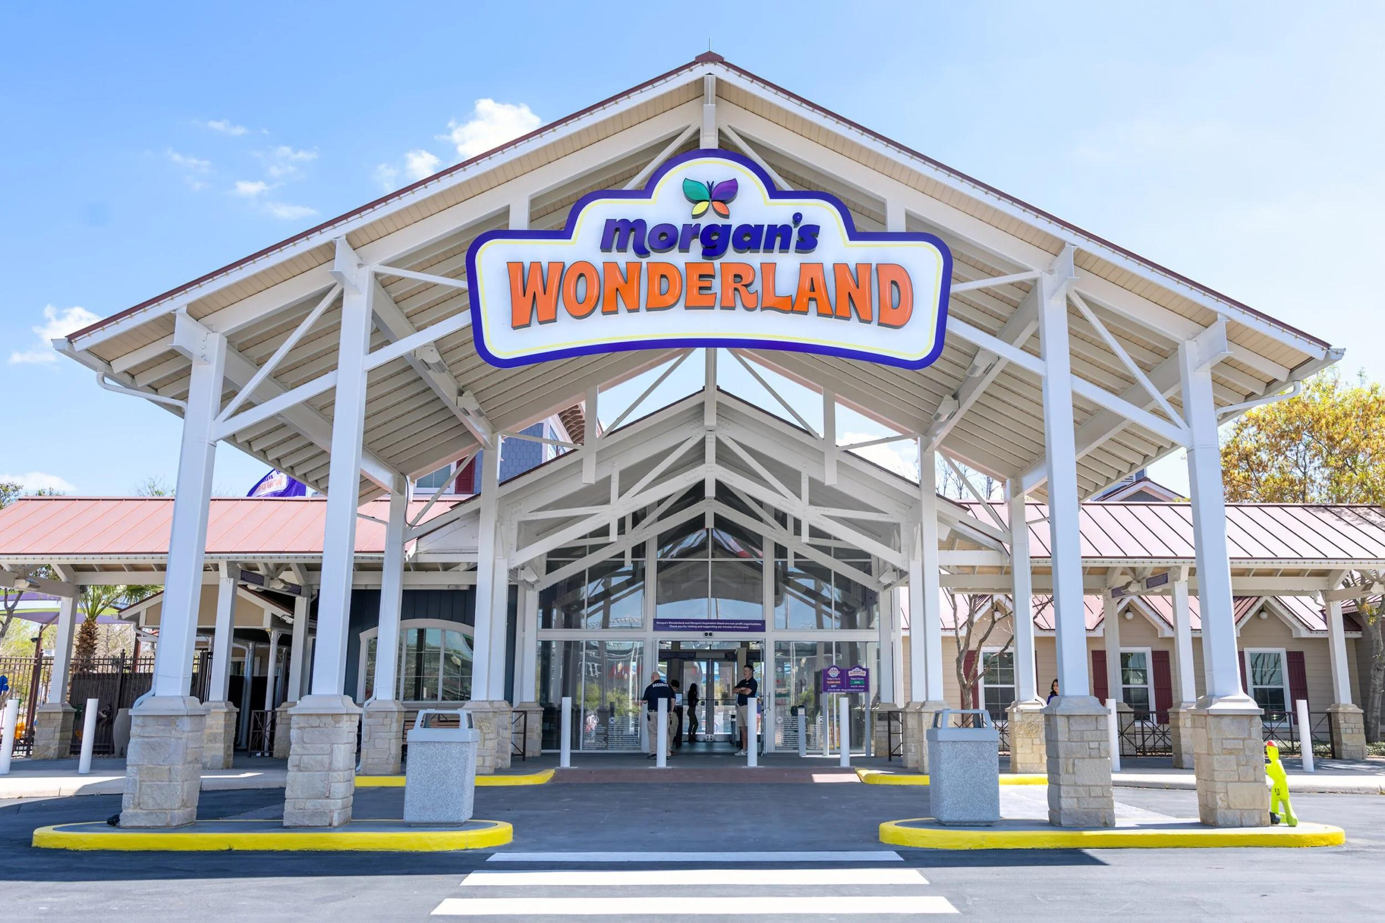
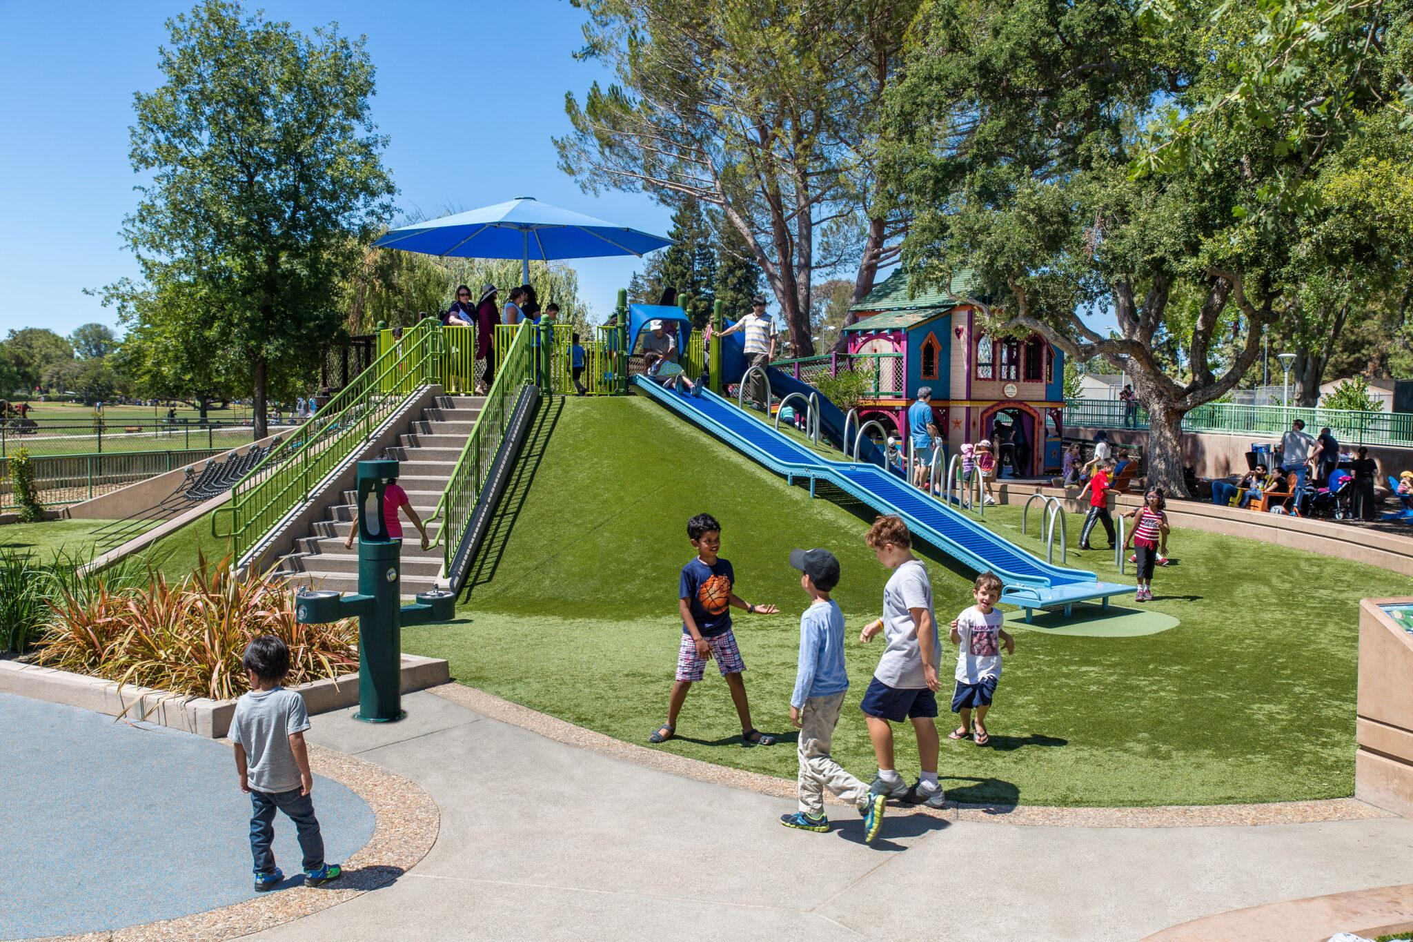
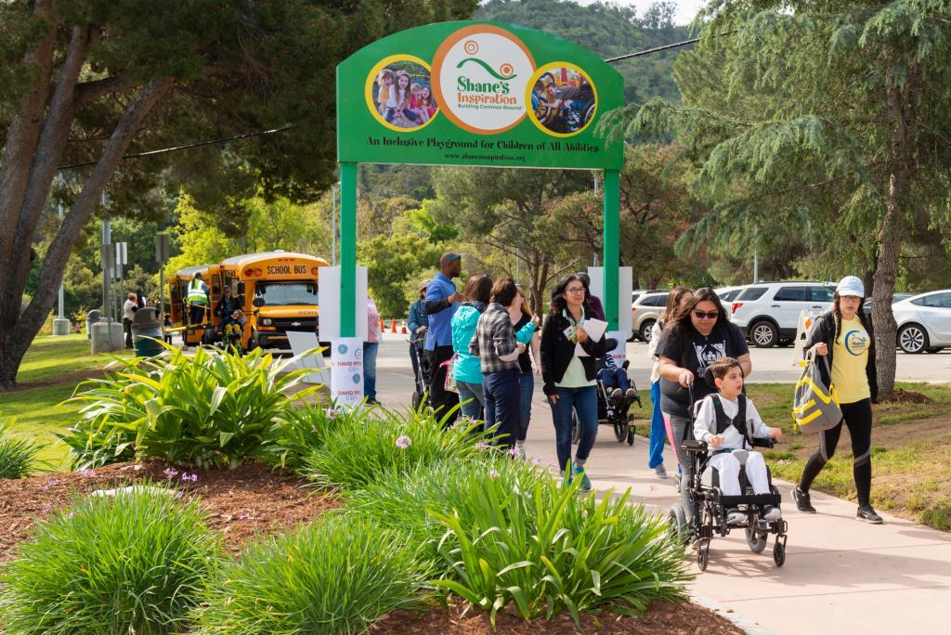
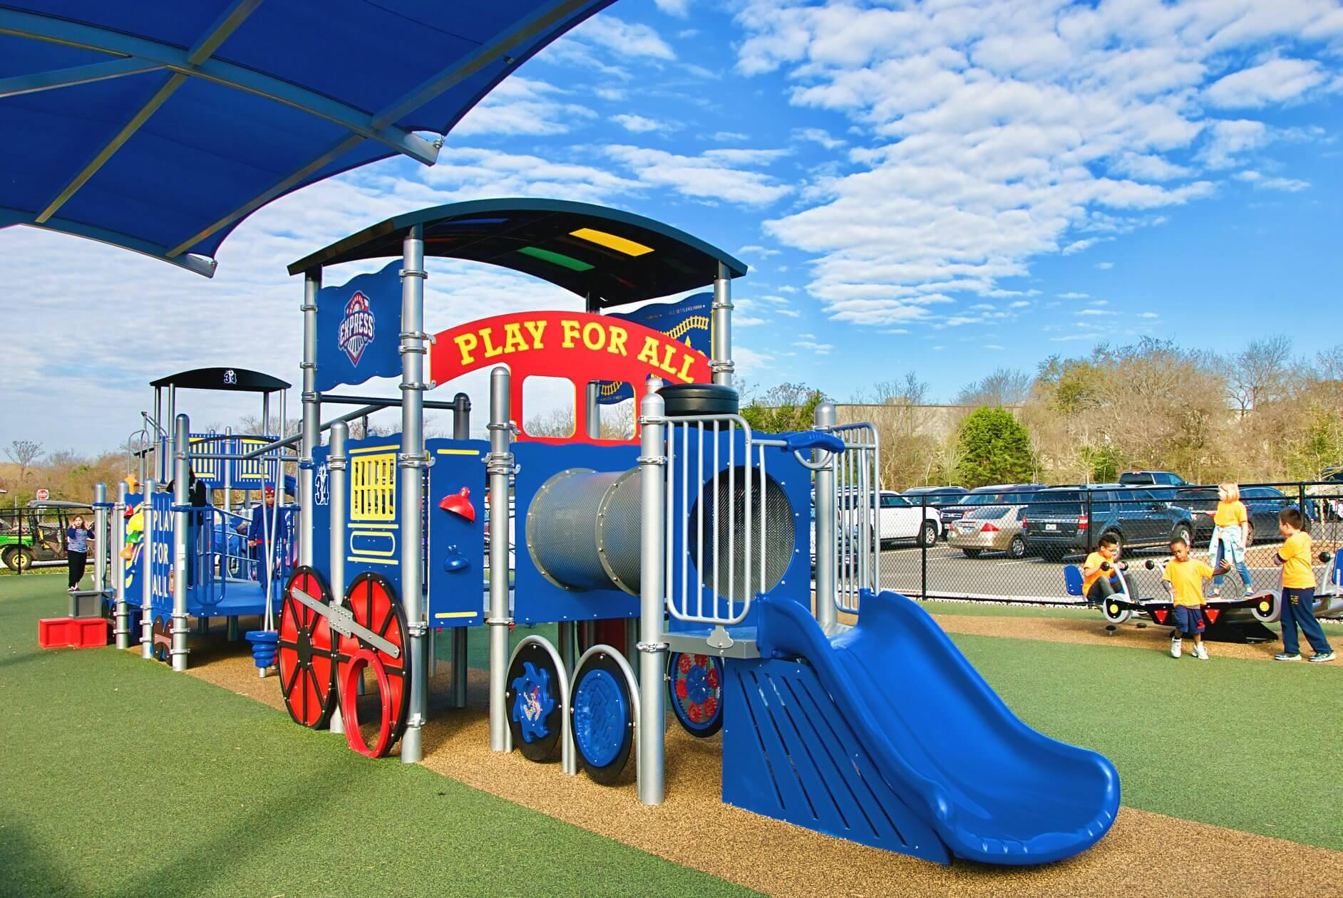
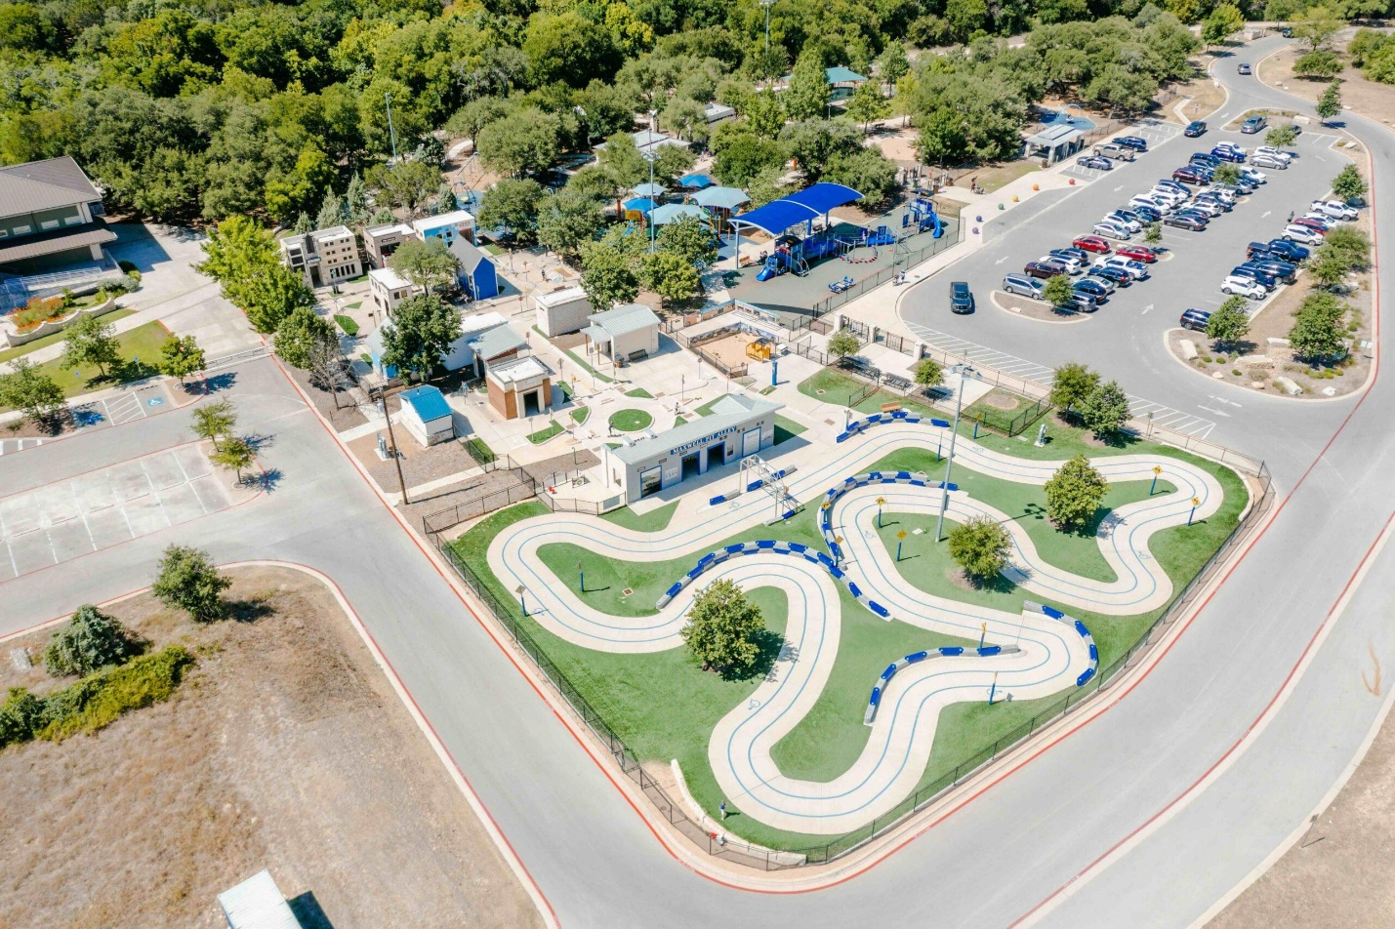
Below are some of the best-known adapted, accessible, and inclusive parks/playgrounds in the United States. These parks are designed to welcome children of all abilities with features such as wheelchair-accessible surfaces, adaptive swings, sensory play, quiet spaces, communication boards, and inclusive equipment. (Accessible Playground)
State | Park | City | Website
Alabama | Magic City Discovery Park | Birmingham | https://magiccitydiscoverycenter.org
Arizona | Esperanza Inclusive Playground | Phoenix | https://www.phoenix.gov/parks
Arkansas | Creekside Park Inclusive Playground | Bentonville | https://www.bentonvillear.com
California | Magical Bridge Playground | Palo Alto | https://www.magicalbridge.org
California | Shane's Inspiration Playground | Los Angeles | https://www.inclusionmatters.org
California | Aidan's Place | Los Angeles | https://www.inclusionmatters.org
Colorado | Inspiration Playground | Fort Collins | https://www.fcgov.com
Connecticut | Jonathan's Dream Playground | Cromwell | https://jonathansdream.org
Delaware | Abessinio Family Wilmington Riverfront Park | Wilmington | https://riverfrontwilm.com
Florida | Lakes Park Inclusive Playground | Fort Myers | https://www.leeparks.org
Florida | Unity of Inclusion Playground | Jacksonville | https://www.coj.net
Georgia | Morgan Falls Overlook Inclusive Playground | Sandy Springs | https://www.sandyspringsga.gov
Illinois | Dan Ryan Woods Inclusive Playground | Chicago | https://fpdcc.com
Indiana | Murphy Inclusive Playground | Carmel | https://www.carmelclayparks.com
Iowa | Miracle League All Inclusive Playground | Urbandale | https://www.miracleleagueiowa.com
Iowa | Gabe's All Inclusive Playground | Davenport | https://www.inclusionmatters.org
Kansas | Sedgwick County Boundless Playground | Wichita | https://sedgwickcounty.org
Kentucky | Wendell Moore Inclusive Playground | Louisville | https://www.bestparksever.com
Louisiana | Lafreniere Park Inclusive Playground | Metairie | https://lafrenierepark.org
Maryland | Hadley's Park | Potomac | https://montgomeryparks.org
Massachusetts | Pope John Paul II Park Inclusive Playground | Boston | https://www.mass.gov
Michigan | Kids Together Playground | Holland | https://www.cityofholland.com
Minnesota | Central Park All-Abilities Playground | Maple Grove | https://maplegrovemn.gov
Mississippi | KidsTowne Inclusive Playground | Ridgeland | https://ridgelandms.org
Missouri | Destiny's Playground | Columbia | https://www.como.gov
Nebraska | Trago Inclusive Playground | Omaha | https://omahaparksfoundation.org
Nevada | Sparks Marina All-Abilities Playground | Sparks | https://cityofsparks.us
New Hampshire | Livingston Park Inclusive Playground | Manchester | https://manchesternh.gov
New Jersey | Jake's Place | Cherry Hill | https://camdencounty.com
New Mexico | North Domingo Baca Inclusive Playground | Albuquerque | https://cabq.gov
New York | Mariposa Playground | New York City | https://www.nycgovparks.org
North Carolina | Kids Together Playground | Cary | https://kidstogethercary.org
North Dakota | Sertoma Inclusive Playground | Bismarck | https://bisparks.org
Ohio | Boundless Playground | Westerville | https://westerville.org
Oklahoma | Gathering Place Adventure Playground | Tulsa | https://www.gatheringplace.org
Oregon | Harper's Playground | Portland | https://www.harpersplayground.org
Pennsylvania | Smith Memorial Playground | Philadelphia | https://smithplayground.org
Rhode Island | Goddard Memorial Inclusive Playground | Warwick | https://riparks.ri.gov
South Carolina | Kids Garden Inclusive Playground | Myrtle Beach | https://myrtlebeachsc.gov
South Dakota | Storybook Island Inclusive Playground | Rapid City | https://storybookisland.org
Tennessee | Shelby Farms Woodland Discovery Playground | Memphis | https://shelbyfarmspark.org
Texas | Morgan's Wonderland | San Antonio | https://www.morganswonderland.org
Texas | Morgan's Inspiration Island | San Antonio | https://www.morganswonderland.org
Texas | Play for All Abilities Park | Round Rock | https://www.roundrocktexas.gov
Texas | Ed Thompson Inclusive Park | Pearland | https://www.inclusionmatters.org
Utah | All Together Playground | Orem | https://orem.org
Vermont | Kiwanis Inclusive Playground | Burlington | https://enjoyburlington.com
Virginia | Chessie's BIG Backyard | Williamsburg | https://www.williamsburgfamilies.com
Washington | Providence Playscape at Riverfront Park | Spokane | https://www.inclusionmatters.org
West Virginia | St. Albans Inclusive Playground | St. Albans | https://stalbanswv.com
Wisconsin | Madison Inclusive Dream Park | Madison | https://cityofmadison.com
Wyoming | Kid's Korner Inclusive Playground | Cheyenne | https://cheyennecity.org
For finding additional accessible playgrounds by state, these directories are among the most comprehensive:
- Accessible Playgrounds Directory
- Find Accessible Playgrounds
- Inclusion Matters Playground Map
These resources maintain searchable databases of inclusive playgrounds across the U.S. and are updated as new parks open. (findaccessibleplaygrounds.com)

